DIRTY LAUNDRY
SHAKE AND THROW OUT WORN ITEMS

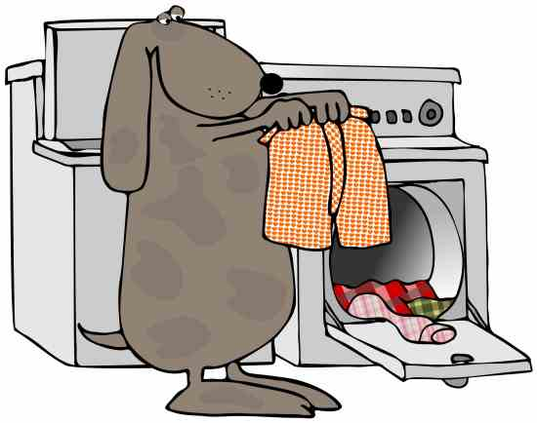

No Poop or cat litter in the washer

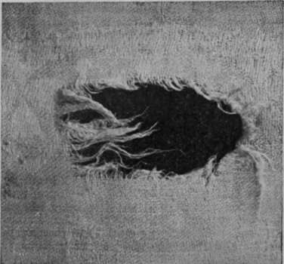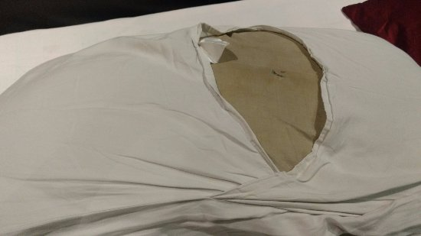

If worn or torn, toss it out

2
WASHING
CHECK DRAIN, LOAD, START x3

Remove any stuff from drain behind washers
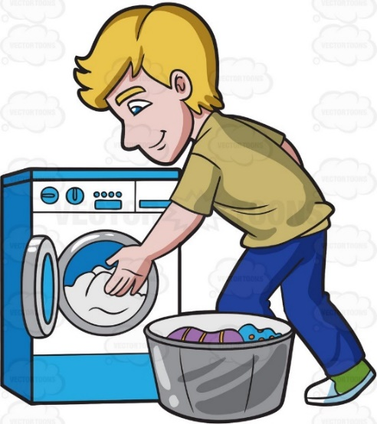
Load Washers
Push ‘START’ 3 or 4 times. Wiggle handle if it doesn’t start. Repeat as needed
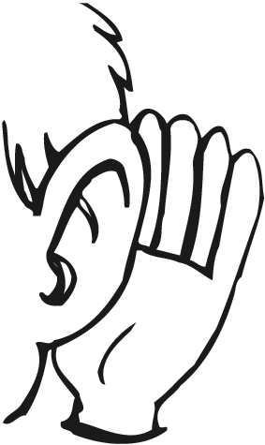
Listen for door to latch and water to fill machine before leaving

3
DRYING
NO COLLARS / LEASHES, REMOVE LINT, START

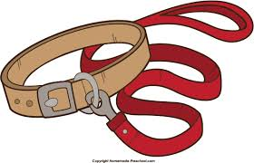
Do not put collars / leashes in dryer

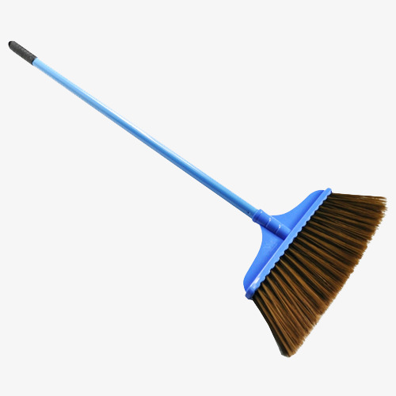
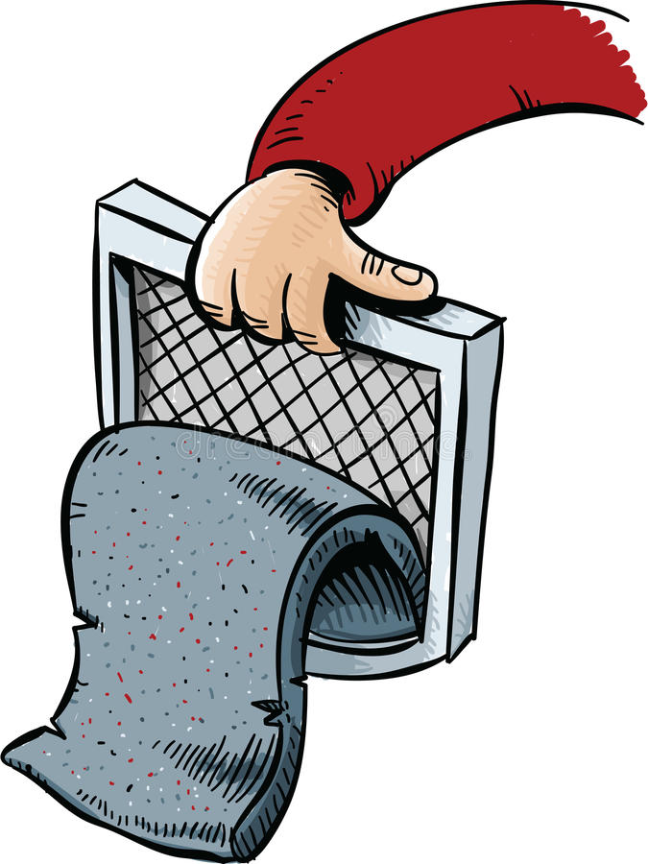
Remove door, sweep lint out, replace door and throw out lint. Check seal around door for lint.
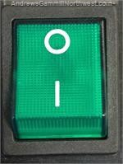
Push green START button

4
CLEAN LAUNDRY
SORT AND PUT AWAY

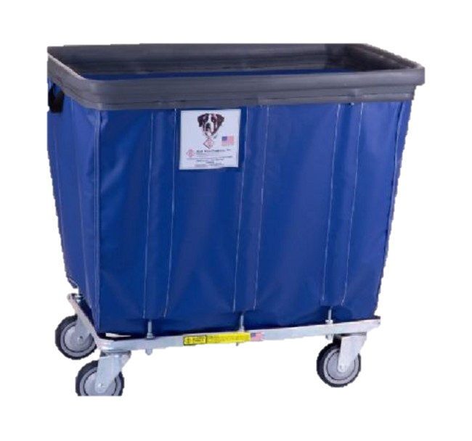
Pull dry laundry into bins

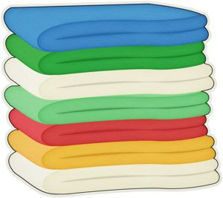
Fold and put away in appropriate locations

Bandanas – Behavior Office Thin Slip Leads – Kennel Kitchen
Beds – Shelves Sturdy Slip Leads – rack in Kennels
Toys – Bins under tables Scrub Clothes – Shelf in hall
Collar/Leash – Hook on shelf

NOT SURE - JUST ASK!

