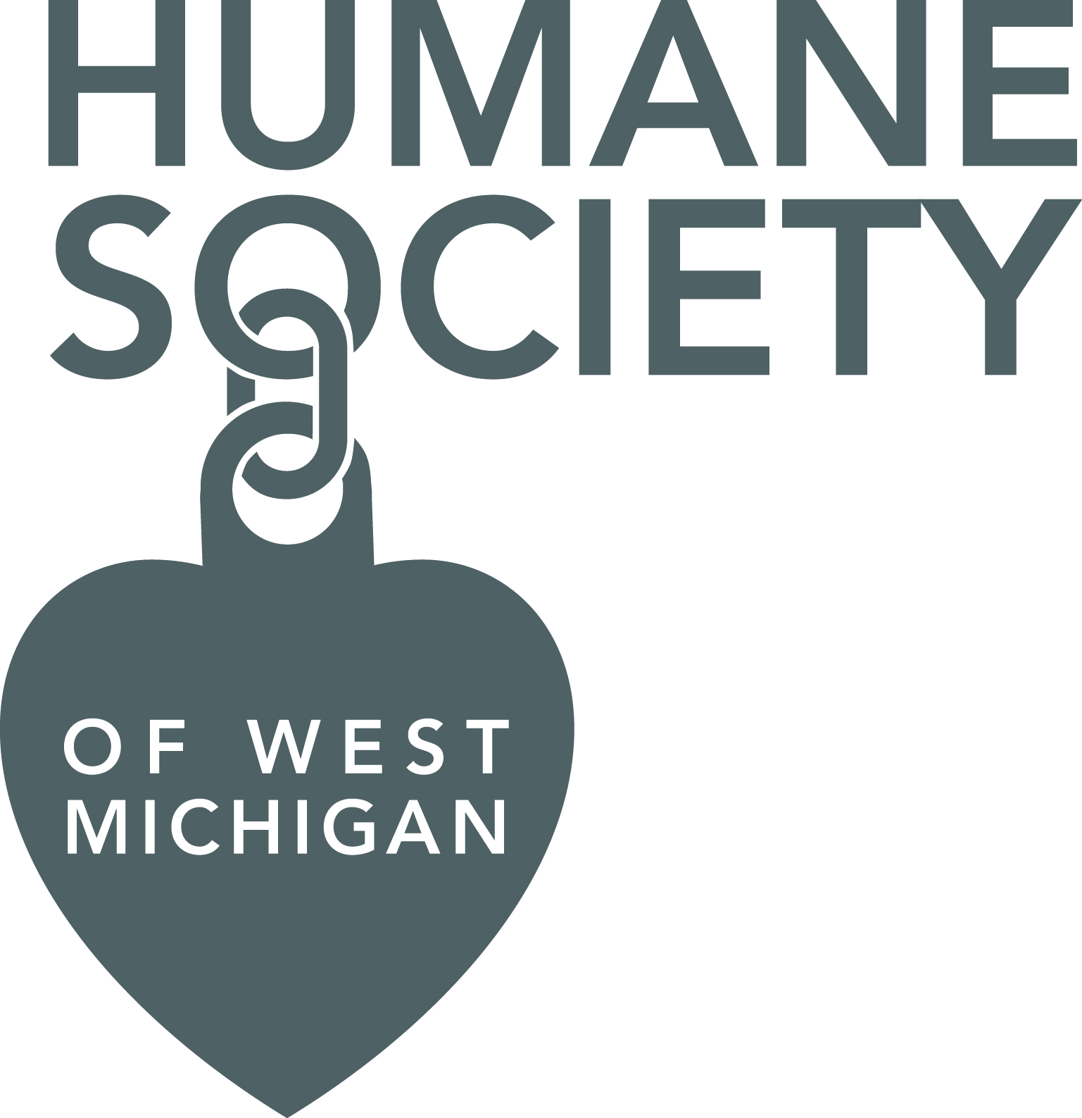
HEARTWORM CLAUSE
As the adopter of this dog, I understand the following information concerning the adoption and his/her heartworm testing/treatment.
- Even though my dog has tested negative for heartworm (whether at Humane Society of West Michigan or their source shelter), there is still a possibility that he/she may test positive after leaving our facility.
- Dogs that come to Humane Society of West Michigan from source shelters in the south, where heartworm positive incidences are higher, may be at a greater risk of exposure to heartworm infection.
- I am responsible for receiving the proper medical care and treatment from my veterinarian for my animal once he/she leaves Humane Society of West Michigan.

_______________________________________ _______________________________________
Print Name Date

_______________________________________ _______________________________________
Sign Name HSWM Witness

