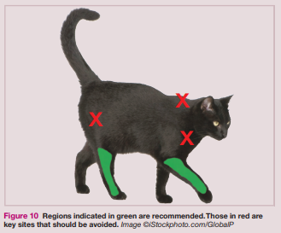
AC-04 VACCINES – CAT FLOWCHART
Update as needed:

Vaccine | Earliest Age | Booster Frequency | Location
Rabies | 12 wks old | N/A | Rt Rear LEG
*Distemper (FVRCP) | 4 wks old | Every 2 weeks until 20 weeks old | Rt Front LEG
Bordetella | 4 wks old | N/A if given after 8 weeks of age.  If younger, every 2 weeks until 8+ weeks. | Intranasal

If started when age is over 20 weeks (5 months) – Only ONE booster needed after 3 weeks.

*If more than 6 weeks since previous vaccine, start over.

Initial vaccines should be started at a time when boosters can
all be done together.

Enter in ShelterLuv with appropriate next due date.

FVRCP
Rabies
Cat has vaccine information from a veterinarian with them?
(If no records or you cannot contact a clinic, assume they are NOT up-to-date)

Enter vaccine information provided in ShelterLuv with appropriate due dates.
Label as “prior to intake” with the administering veterinary clinic in the exam notes.
YES
NO
Vaccines Needed
NO

