AC-12 CAT CLEANING & CARE

Purpose
To detail the positions and responsibilities of staff working in the cat cages, rooms and med room and specifics on how the processes are to be completed.

Policy
Cattery staff will ensure all cages and cat housing areas are clean and sanitary for housing cats and kittens.

Staff /Areas Affected
- Cattery Staff / Med Room Staff
- Feline Enrichment Coordinator
- Admitting staff (Holding)
- Vet staff

Definitions
ISO – Isolation (located inside room 218)
ShelterLuv – Database used by HSWM for all tracking of customers, animals and associated service
URI – Upper Respiratory Infection

Responsibilities – Director of Animal Care is responsible for making sure this process takes place.

Procedures
This procedure is to be followed when there is no known presence of Giardia or other contagious disease in the general population of housed animals. When illness is known in house, please refer to specific procedures for additional cross contamination procedures. Checklists must be completed by each person every shift and turned in to supervisor.

Priority

Care for as follows:
- Rabbits & other small animals
- FeLV + kittens/cats
- Healthy kittens
- Healthy adults
- Sick kittens
- Sick adults

Things to remember:
- Always clean healthy animals first, then move on to sick animals to avoid cross contamination.
- If Giardia, Coccidia, etc. is ever suspect, collect a sample and submit to Vet staff for fecal test and note.
- If disease is suspect, do NOT use that litter scoop on subsequent litter boxes. Sanitize it, and get a new one for the remaining litter boxes.
- Keep noise levels to a minimum at all times. Noise, including loud conversation and laughing can be stressful to cats. Try to not slam cage or lobby doors. Speak in a soft voice.

Daily Schedule:
Attend to laundry upon arrival. Load, move, start machines as needed.

Position A – Small animal cages, Lobby rooms, garage cats, shed cats
Position B – Petco-Alpine (b4 arriving at shelter ) Cattery Colonies 1-5, Condos, Cat Behavior office (on days when Behavior Coordinator is not working)
Cat Holding 1 – Done by Admitting Staff, Cat Holding 2 – Done by Foster Coordinator or Admitting Staff

 | A (7:00-3:30) |  | B (9:00-5:30) |  | Cat Holding 1
1 | Distribute meds as needed | 1 | Clean cages at Petco | 1 | Distribute meds as needed
2 | Care for working and garage cats (See SOP AC-16) | 2 | Distribute meds as needed | 2 | Clean cages (see below)
3 | Clean Small Animal cages (*see below) | 3 | Small Animals (*see below) | 3 | Feed & water
3a | Feed and water small animals (see below) | 4 | Remove ‘Please don’t pet me today’ signs if cat is healthy | 4 | Clean cages (see below)
4 | Clean lobby rooms (see below) | 5 | Return previous day’s colored Socialization/paper clips to door | 5 | Feed & water
4a | Feed & water Lobbies (see below) | 6a | Clean Colonies (see below) | 6 | Scoop or empty Litter boxes
4b | Scoop or empty Litter boxes | 6b | Feed & water | 7 | Log all medical concerns and fill out/hang hospitalization forms on cages (See M-16)
5 | Empty urine into collection bottles | 6c | Scoop or empty Litter boxes | 8 | Clean and set up vacated cages
6 | Log medical concerns*, fill out/hang hospitalization forms & hang ‘I’m not feeling well’ signs (See M-16) | 7a | Clean Condos (see below) | 9 | Clean dirty cat carriers with Rescue
7 | Clean and set up any vacated colony | 7b | Feed & water | 10 | Wash dishes & toys
 | LUNCH | 7c | Scoop or empty Litter boxes | 11 | Wash litter boxes & scoops
8 | Wash dishes & toys | 8 | Clean, feed and scoop Cat Behavior Office is applicable | 12 | Restock supplies
9 | Wash litter boxes & scoops | 9 | Clean / tidy up Colony 3 for meet and greets | 13 | Second feeding
10 | Enrichment | 10 | Foam once a week (Wed) Colony 3 and any empty colony | 14 | Clean dirty cat carriers with Rescue & store above cages
11 | Restock supplies | 11 | Log all medical concerns and fill out/hang hospitalization forms on cages (See M-16) | 15 | Clean dirty cat carriers with Rescue & store above cages
12 | Take trash & recycle to dumpsters |  | LUNCH | 16 | PreOp cats when no vet staff in building
13 | Help Position B as needed | 12 | Wash dishes & toys | 17 | Submit Checklist to supervisor
 |  | 13 | Wash litter boxes & scoops
 |  | 14 | Enrichment
 |  | 15 | Take trash & recycle to dumpsters
 |  | 16 | Second feeding all areas
 |  | 17 | Help Position A as needed
- - Consults as needed throughout the day - -

 | Cat Holding 2
1 | Distribute meds as needed
2 | Clean cages (see below)
3 | Feed & water
4 | Scoop or empty Litter boxes
5 | Log all medical concerns and fill out/hang hospitalization forms on cages (See M-16)
6 | Clean and set up vacated cages
7 | Clean dirty cat carriers with Rescue & store above cages
8 | Wash dishes & toys
9 | Wash litter boxes & scoops
10 | Restock supplies
11 | Take trash & recycle to dumpsters
12 | Second feeding

* Submit a Vet Check in ShelterLuv when not eating for 2 consecutive meals, URI or diarrhea.
In ShelterLuv: Find the animal – Medical tab – Health Consult tab – Request Health Check button, select Vet Check, complete requested info, click ‘Save’.

Weekly Schedule:
Sunday | Spot Clean. Deep clean & replace linens *as needed | * As needed – soiled with vomit, poop/ diarrhea or wet
Monday | Foam Colony 3  Deep Clean – keep existing linens if clean
Tues- Sat | Spot Clean. Deep clean & replace linens *as needed
When a Lobby Room is empty, deep cleaned /sanitized all hard surfaces including walls and floors.

Cleaning Cages, Condos and Colonies and Lobby Rooms
- Always make time to pet and touch each animal. This will give you an idea if they are thin, their coat is disheveled or they appear sick.
- To prepare a spray bottle, one full pump of Rescue, fill remainder with water. Rescue is stored in the Med Storage Room near PreOp.
- Do not spray into the cage/condo, spray onto the wash cloth.
- Condos & Cages - Move the cat to one side. Close the porthole in condos, wipe walls, top, bottom door bars, porthole and under shelves When done, move the cat to the other side and repeat.
- Scoop litter boxes and replace when sides are dirty with feces or vomit. Dump once a week as directed by weekly schedule.
- One or more wash cloth(s) per condo/cage as needed. Never use one washcloth on multiple cages.
- Clean walls, top, bottom and cage bars of all debris.
- Replace any wet/dirty bedding only. Shake out any dry food or litter and fold/tidy up linens
- URI cats – change out ALL dishes with clean ones (See SOP M-16 for care of sick cats)
- Soiled linens should be removed, not covered up
- When a cage is vacant, empty, clean and set up so bedding can be removed without lifting beds or boxes when occupied.
- Clean fountains Tuesday and Friday. Grey stuff that collects at the bottom is mold, and needs to be scrubbed off.
- Lobby Rooms 1-2, when vacant: Rinse, foam, scrub, rinse and dry
- Urine collection boxes (As directed when in use) must be emptied into bottles and stored in refrigerator each day (prior to opening). Collected urine is used by Bissell and must be collected and stored properly prior to pick up, unless otherwise directed.
- If diarrhea is present, do not use scoop on subsequent litter boxes. Put near sink for sanitizing and get another scoop to proceed
- Lobby Rooms 4-5, whenever possible, disinfect walls & cat trees (remove scratch pads from cat trees, spray thoroughly with Rescue, wipe with a cloth, lay flat to dry, replace) & mop floors with MicroChem
- Colony 3 - Foaming is done once per week on Monday. Other days, spot clean, sweep and tidy for meet and greet use.
- Foaming in other colonies is done when there are no occupants, and then reset for new occupants.
- Complete checklist as you go

Feeding
- Provide each cat with ¼ cup of fresh dry kibble. Watch for special diet signs, and feed accordingly.
- If cats are not eating, offer other food options in shallow bowls.
- For cats not eating: offer other options (canned, etc.). Use only a spoonful of food when trying to options, so as not to waste an entire can. fill out/hang a “monitor appetite” sign.
- Pate’ style canned food should be provided for kittens. It should be cut/mashed up a bit. For younger kittens add a little water to it and mix it in, until they are consistently eating straight canned food.
- Kittens should always have ceramic bowls, as they are more difficult to flip over with activity
- Canned food dishes should be changed out daily, not reused
- URI cats – change out all dishes for clean ones with each feeding (SOP M-16)
- Provide ½ - ¾ cup of fresh water per cat
- Second feeding, feed cats another ¼ cup of dry food. If a cat has not eaten the morning food at this time, try giving them a spoon of canned food instead of dry
- Complete checklist as you go

General Cleaning
- Dishes - Soak for 10 minutes in soap and hot water. Scrub off all Residue. Rinse. Soak dishes in Rescue solution for 10 Minutes. Rinse. Any surface that is not completely submerged, must be sprayed with Rescue. Air dry on towel next to sink. Wash all dishes before other items. Toys, wash after dishes but before Litter boxes/scoops.
- Litter boxes, scoops – Remove all feces and litter into trash bin. When they need to be washed, soak for 10 minutes in soap and hot water. Scrub off all Residue. Rinse. Soak dishes in Rescue solution for 10 Minutes. Air dry. Clean scrub brush in the same manner
- Broom and dust pan should be cleaned after litter boxes, in the same manner, whenever Giardia or other litter born disease is suspect.
- Clean and disinfect sink area, counters & lobby cart
- Take dirty laundry to laundry room
- Sweep, mop cattery floor using Micro-Chem. Mondays - ShaZyme Degreaser, in place of Micro-Chem.
- Restock supplies (food, toys, blankets, towels, beds, washcloths, litter, paper towel, shredded paper, trash bags, etc.)
- Take trash and recycling to dumpsters
- Clean dirty carriers with Rescue, then store above cages.
- Complete checklist as you go
- Never use sponges for cleaning dishes or litter boxes
- Never put Clean linens over the top of dirty/wet linens
- Never risk cross contamination which spreads disease

SMALL ANIMAL CARE
Rabbits | Guinea Pigs ,Hamsters, Gerbils, Rats, Mice, etc. | Other animals
Clean spilled water and remove feces and wet paper or litter. | Clean out all feces, dry spilled water, remove dirty litter | As directed
Replace with enough litter to cover bottom of litter box and soak up urine. | Provide fresh food and water
Provide fresh food and water | Sweep floor & tidy up as needed
Sweep floor & tidy up as needed
Give paper tube/chewy rolls and toys | Give paper tube/chewy rolls and toys, appropriate to species
Always use ceramic bowls for food and water. (Harder to flip over than metal) | Initial small critters checklists as you work
Initial small animal checklists as you work

LOCATIONS
The decision to move cats is made by the Feline Enrichment Coordinator and/or Director of Animal Care. Once the decision is made to move a cat it should be put in a clean carrier for the move to the new location. Covering the carrier with a towel helps minimize the stress to the cat.

When moving cats/kittens to a new location, linens in the original location should be moved to the new location if they are not soiled, along with any toys, door wash cloth and scratcher, whenever possible. ShelterLuv is updated with the new location.

On their first day in the shelter and longer when needed, every cat needs a hiding spot (cardboard box or paper bag.) Cage should be set up with a hiding spot before putting a new cat into it. Hiding spot can be removed when cat is coming out regularly to seek attention.

Cat Holding Placement

Fill one bank of cages (the right side when you enter the room) before adding cats to the left side. This will eliminate the stress of looking directly at each other. Place cats in cages at the far end, near the window first.

Place senior cats, kittens, FeLV: upper cages. These groups are most vulnerable to URI and when they're in uppers, there will be no one sneezing down on them.

Save bottom cages for the cats that are friendly and easy to handle on intake. Fearful cats will do better in upper cages - they feel safer higher off the ground

Caution cats - Avoid putting another cat right next to them. Stress is contagious!

Reference Documents
- SOP M-16 Isolation
- SOP AC-16 Working Cat Care
- Checklists – specific to Rooms/Locations
- Addendum to this SOP, attached – Med Room Cage Set up
Revision History
V1 - Created 5/21/19
V2 - Updated 1/22/20
V3 – Updated 3/12/20
V4 – Updated 4 8/3/20
V5 – Updated 8/17/20
V6 – Updated 9/14/20

Med Room Cage Setup

Cages with Kuranda beds:
The blanket on the bed should overhang to create a hiding spot underneath it. To prevent slipping as a cat jumps onto the bed, pull the blanket back behind the bed a little. Always leave a couple inches between the blanket drop and the cage floor so we can peek in at the cat even when they’re hiding. Set up so bedding can be removed as needed without lifting the kuranda bed.

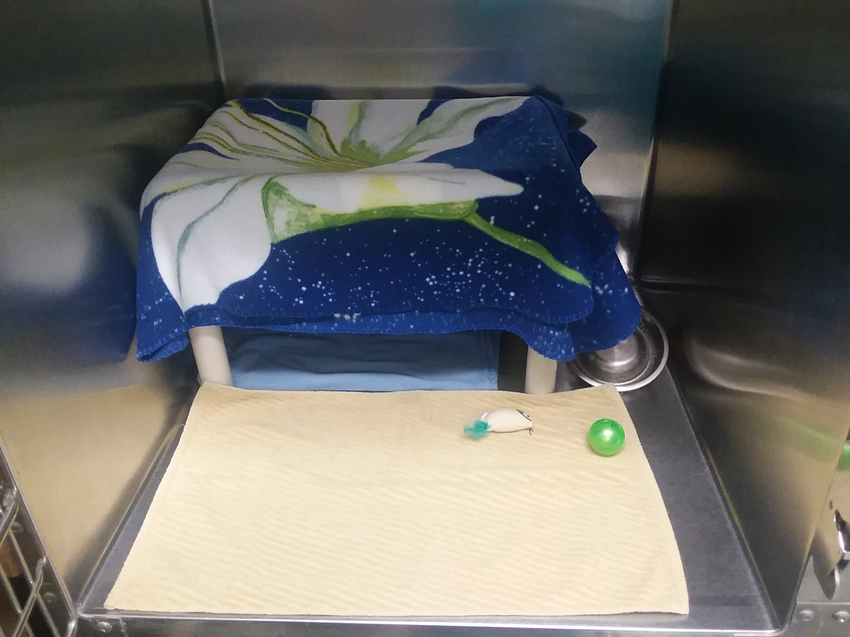

Cages without Kuranda beds:
New cats always need hiding spots. Set up so soiled bedding can be removed as needed without lifting the hidey box or paper bag (left). Once a cat no longer needs a hiding spot, set up like right photo. Always try to place food/water dishes “kitty corner” from litter boxes.

