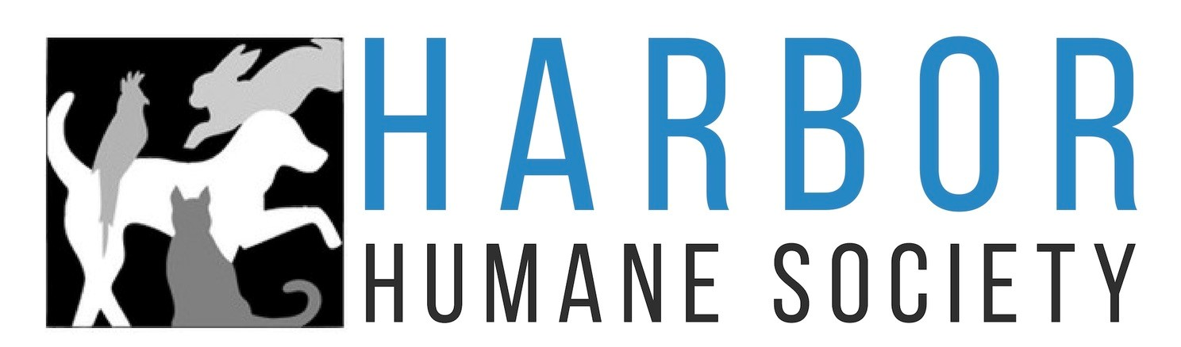

CAT ADOPTION SURVEY
Name |  |  |  | Date
Address |  | City |  |  | State/Zip
Primary Phone | Secondary Phone |  | Email

These questions are not used to determine whether or not you will be allowed to adopt a pet, they just help us ensure that
the cat you do adopt will fit comfortably into your social life, so there are no "wrong" answers.

Are you 18 years of age or older? ⃝Yes ⃝No

Do you OWN or RENT? If you RENT or live in a community with guidelines, what is the cat policy? ______________________________________________

Routine Living:
Other pets I currently have in my home are:
Type | Name | Breed | Age | Gender | Spayed /  Neutered | Indoor / Outdoor | How long owned? | Last Vet Visit

Which veterinary hospital or clinic do you use? ____________________________________________
Under whose name(s) are the records kept? ______________________________________________
Routine Living

The household for my new pet would be described as: (circle one): slow/quiet middle of the road busy/active
People my new cat will have frequent/regular contact with (e.g. elderly, young children, daily, weekends, etc.):

My new cat will: | Yes | No | Additional comments
Have other pets come to our home for visits, etc.
Have play dates with pets of other friends/family members
I plan to provide scratching posts
Be alone how many hours per day?
List activities you will typically do with the cat:
The main reason I am planning to adopt a cat is:
Traits I want in a cat are:
I plan to have this many litter boxes in my home:
The amount of time I feel is reasonable for my new cat
to adjust to my home?
My ideal cat would:
(Give any feedback that would help us find the perfect cat for you.)

Social Interaction:
My new cat will: | Yes | No | Other – please explain
Interact with children who visit but who don’t live with me
Go to the home with friends/relatives while we are out of town
Primarily be an inside cat

What topics you would like to discuss with your adoption Counselor:

Certifications, Authorizations, Releases and Understandings
- I certify that all statements on this Adoption Survey are made truthfully and without evasion, and further understand and agree that such statements may be investigated and if found to be false will be sufficient reason for not being allowed to adopt from Harbor Humane Society, Humane Society of West Michigan, or Kent County Animal Shelter.
- I understand that the organizations have the right to deny any survey as deemed necessary.
- I understand that the handling of animals that I may meet may place me in a hazardous situation and could result in injury to me or my personal property. On behalf of myself, my heirs, personal representatives and assigns, I hereby release, discharge, indemnify, and hold Harbor Humane Society, Humane Society of West Michigan, and Kent County Animal Shelter and its directors, employees, and agents from any and all claims, causes of action and demands of any nature, whether known or unknown, arising out of or in connection with my meeting an animal for the purpose of adoption.
- I understand that I am applying to adopt a shelter cat. There are no guarantees of behavior or health. I am willing to assume all costs for care medical care once adopted.
- I understand that this application will be shared with Harbor Humane Society, Humane Society of West Michigan and Kent County Animal Shelter. I understand this information will not be confidential.
- Additional requirements and fees may vary per location.

Applicant Signature: _______________________________________________________________________ Date: _______________________

OFFICE USE ONLY
Agency Name: ________________________________ Adoption Counselor Name: _______________________
A P D Reason if P or D: _________________________________________________
Notes: ______________________________________________________________________________________

