G-10 MOBILE ADOPTION TRAILER

Transporting – Including prior to movement
Consult the Adoption Trailer calendar (Google Calendars) when plans are made for use. If available, add your event to the calendar.

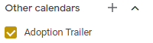

Movement of the trailer should only be done by a licensed CDL driver.

Supplies that should always be in the trailer include minimal supply of:
- Paper towel
- Sanitizing wipes

Prior to movement:
- Crates should remain ratchet strapped to the sides of the trailer prior to use and must remain tightly secured during transport. Check security before movement.
- Check to make sure the 2 stabilizer legs on the back are up and secured with pin
- Visually check tire pressure
- If the generator will be used, be sure it is full of gas
- Confirm the battery has been fully charged
- Confirm the door, ramp and window awnings are closed and locked. Paddle lock code - 0808
- Confirm the roof vents are closed
- Once connected to the vehicle, confirm hitch is locked down and safety chains are secured
- Raise the support with the power switch to its highest point
- Raise the front leg so the weight is on the hitch/vehicle

Set Up at destination
- Locate a level location for set up. Trailer can remain attached to the vehicle.
- Lower the rear two stabilizers and insert pin.
- Lower the step below the side door
- If the rear ramp will be used, unlatch both sides and slowly lower the ramp.
- Unlock and open window awnings if desired.
- Remove the board from the pin in the side and put across the hinge to fill the gap in the floor.
- Flip over the ramp plate at ground level.
- Crates can be unstrapped and rolled outside if need be once the board is in place. Driver side cage bank can be unstrapped and rolled to rear set of windows for visibility.
- Switches by the side door and rear ramp will operate the lights and ceiling vents/fans as needed
- A/C can be used in the ceiling once the generator is running.
- The black cord must be plugged into the generator and the outside of the trailer to use the generator for the power outlets and the AC.

Generator (See photos 1-4 below)
- Fill with gas prior to use. A full tank will run approximately 3-4 hours (Do not believe the meter on the generator, it is misleading.)
- Attach the power cord between the generator and the trailer (See photos 1 & 2 below) before starting the generator.
- Start – (See photos 3 & 4 below)
  - Turn white carburetor switch DOWN to feed fuel
  - Confirm switch is on 120 volts (not 220)
  - Press the Power toggle switch to ‘On’.
  - Press and hold the silver START button until it starts.
- Shut Off –
  - Turn the power toggle switch to ‘Off’
  - Turn the white carburetor lever UP to shut off fuel
- Generator must be running to use the ceiling mounted Air Conditioning unit

1) Power Cord Connection (Generator) | 2) Power Cord Connection (Trailer)
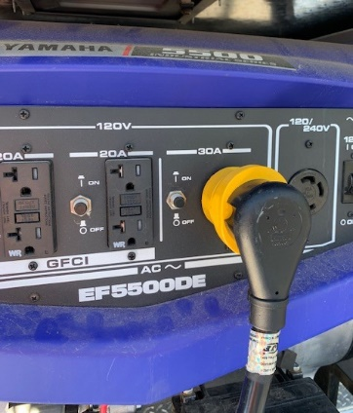 | 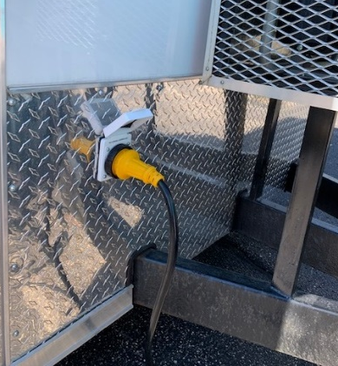
3) Carburetor switch – left side of generator | 4) Generator Power
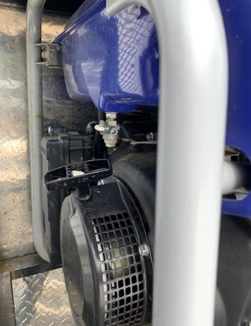  Carb switch | 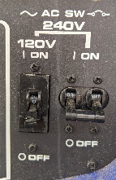  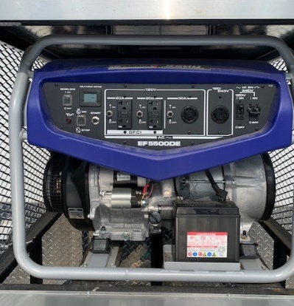  POWER  START

Power switch locations (will operate off battery or generator power)

Switch Locations:
Back Door – lights, ceiling vent and fan | Side Door – lights, ceiling vent and fan
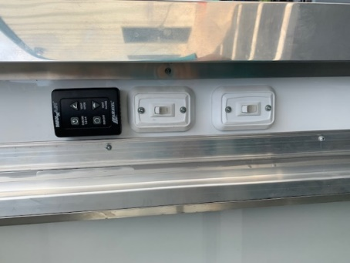 | 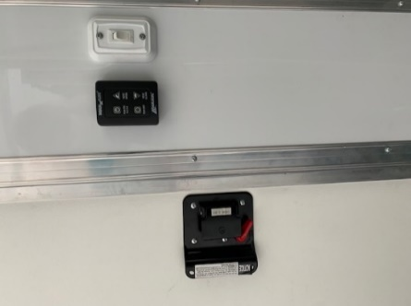
Front lights over cabinets (Behind side door) | **Front Power outlet and USP outlet **These run on Generator power only**
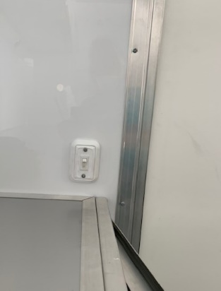 | 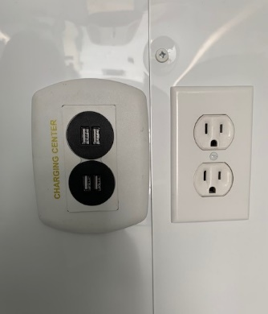

Air Conditioning Unit in the ceiling
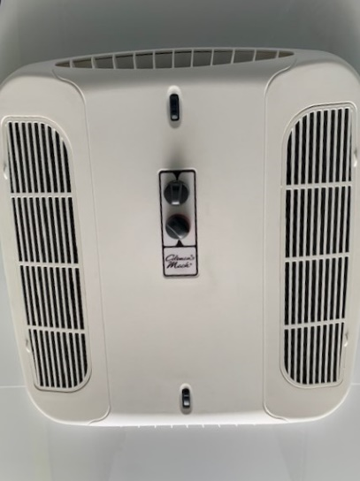 | Adjustment knobs control the temperature are in the center.  Vents can be adjusted to open / close  the front / back.  (Small black knobs near ends of the unit.)

Battery Power
- The battery (inside cabinet next to side door) can operate the lights and ceiling fans for approximately 2-4 hours from a full charge, depending on what is running off from it.
- Generator must be running to use the ceiling mounted Air Conditioning unit

Power from an Extension Cord
- This cannot be used as the trailer is wired for 220 volts only

Before moving
- Raise the stabilizers on the rear
- Raise the side door step

After Use
The trailer must be cleaned and emptied after each use.
- Confirm all doors are locked and trailer is in place and secure before removing hitch from vehicle.
- Clean all kennels/cages with MicroChem. Roll out to completely hose/foam if needed.
- See AC-18 Cross Contamination SOP for proper cleaning.
- Spot clean any other surfaces as needed.
- Sweep and mop if needed.

Trouble Shooting
Hitch | Battery - mounted on frame, behind hitch. (Pulls power from inside battery) | Hand crank to raise/lower on hitch | 7/16” socket with extender to manually lower
 | Ball won’t release from hitch / binds up | Latch mechanism is a two series latch | Pull back as far as you can, then up
Person Door | Upper lock is not needed | Lower lock is the one that actually locks door | Can be a bit touchy. Try a couple times.
Generator | Won’t turn over | Check gas level
Rear Ramp/Door | Left side latch is hard to latch | Pushing in and pulling down requires extra effort on this side

Reference Documents
SOP - AC-18 Cross Contamination

Revision History
Created 9/1/20 – V1
Updated 9/8/20 – V2

