G-13 TRANSPORT DRIVER INFO

TRANSPORT SUPPLY CHECKLIST
Vaccines/Meds for source shelter – if applicable
Water bowls – enough for each crate + 2-3 extra
Bottled water
Puppy slip leads
Adult slip leads
Extra collars/leashes
Soft Treats
Towel inside each crate, + 4-5 extra
Paper Towel and Rescue in a spray bottle
Hand sanitizer & sanitizing wipes
PPE – gloves, masks, gowns, booties, etc. +extra
Extra ratchet straps (above cab)
Human and Animal First Aid Kit
Jumper cables
Folder w Contacts, SOP, emergency protocols, etc.
Insurance paperwork
Remind Driver to review folder prior to leaving
DRIVERS
Phone charger w car adapter (There is a USB port in the van)
Recommended Map Apps (Waze, Apple or Google Maps)
Personal Luggage, masks, meds, water bottle

VEHICLE DETAILS

2014 Dodge Ram ProMaster 2500
Fuel Tank – 24 gal
Height 136” (11.3 ft)
Length 215” (18 ft)
Width 81” (6.75 ft)
Wheelbase 126”
Gross Weight 8,900 lbs,
w crates 9,250, w dogs 9,700

MEAL ALLOWANCE
Breakfast - $5.00
Lunch - $10.00
Dinner - $15.00

Keep all receipts for reimbursement

Photos of crate set up in the van’

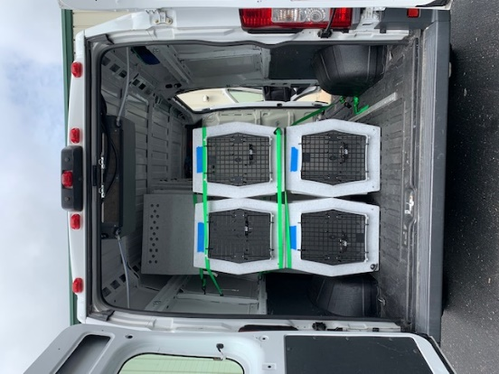 | 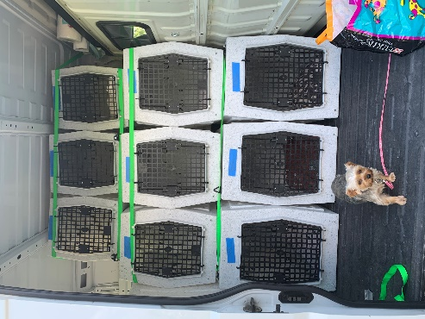
View from Rear doors | View from Side doors

Straps should not encumber opening of crate doors at anytime

Revision History
V1 - Created 7/14/20

HARRTS – Savannah, TN – Towing and Service Recommendations
INDIANA ROUTE
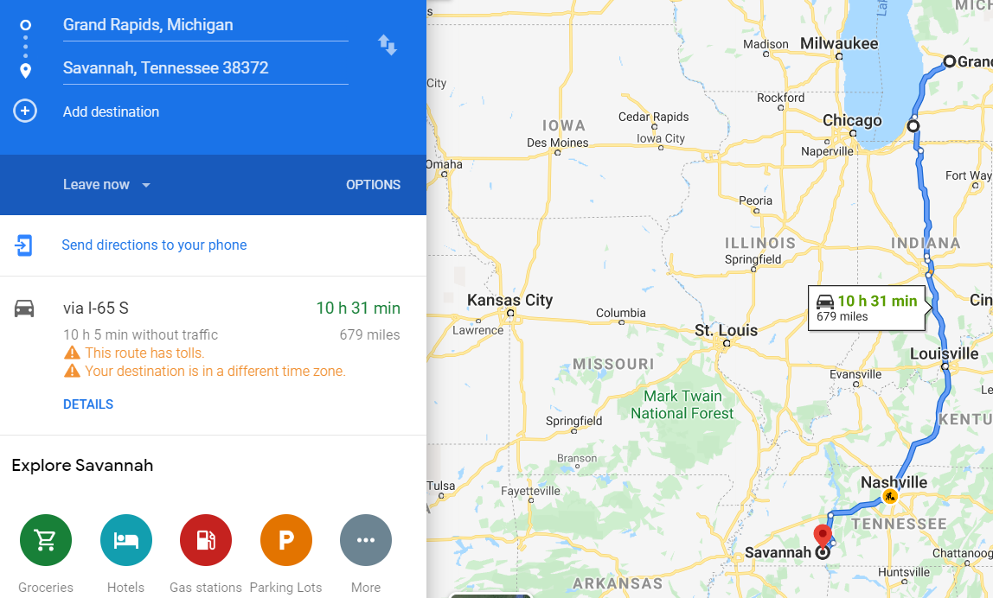

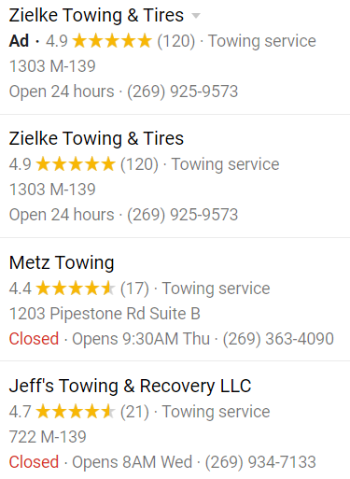
Benton Harbor, MI

South Bend, IN
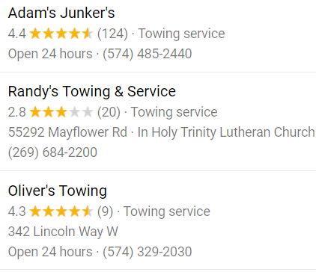
Kokomo, IN
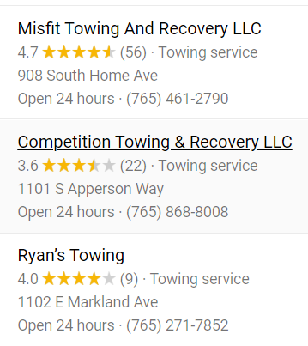
Indianapolis, IN
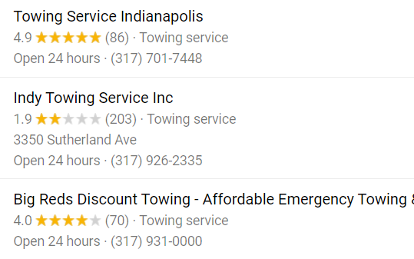

Bloomington, IN
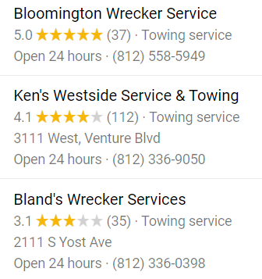
Oakland City, IN
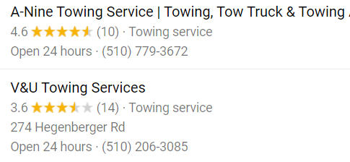
Evansville, IN
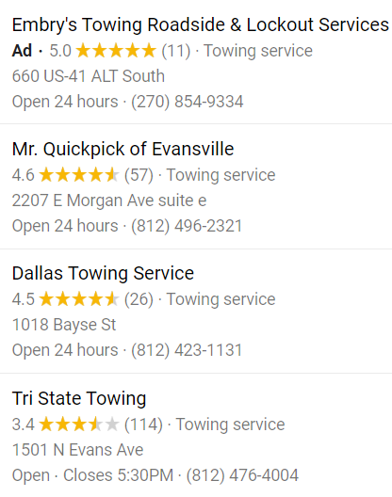
Madisonville, KY
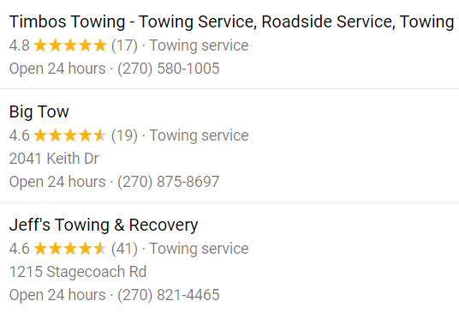
Nortonville, KY
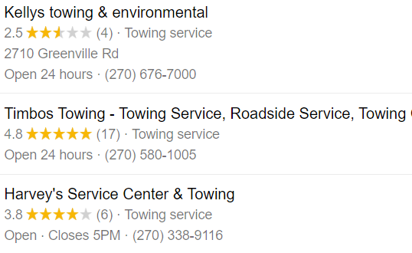
Hopkinsville, KY
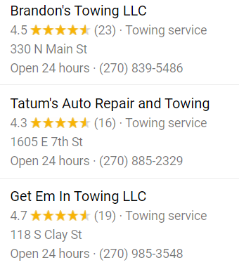
Bowling Green, KY
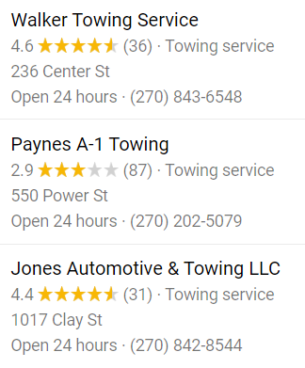
Clarksville, TN
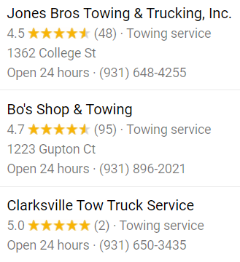
Nashville, TN
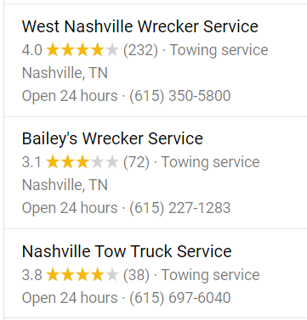

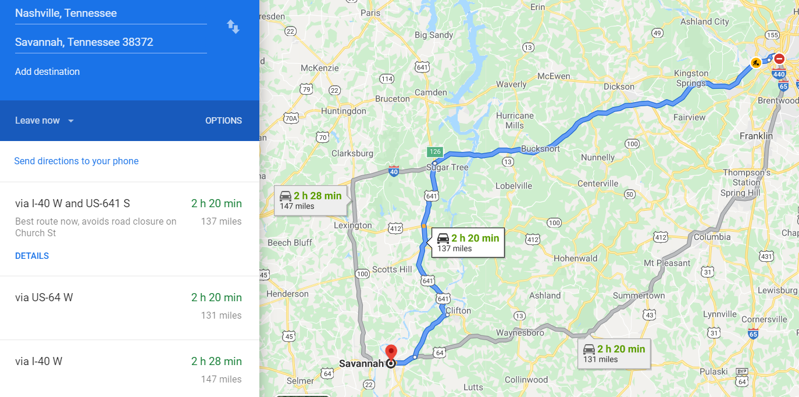
McEwen, TN
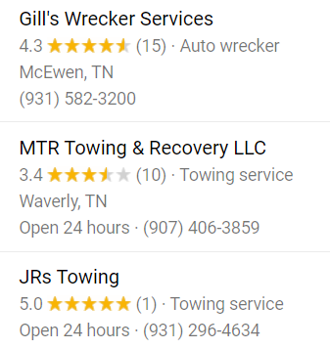
Decatur, TN
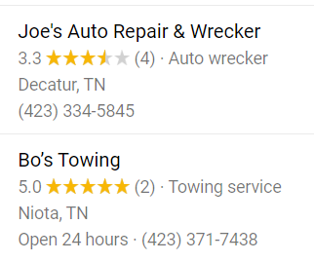

ILLINIOS ROUTE
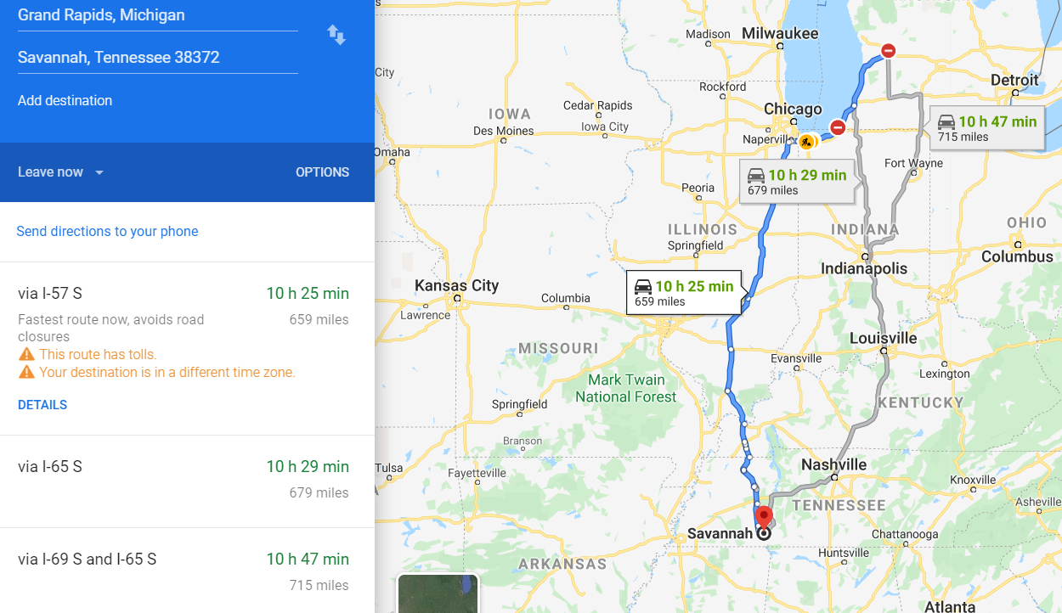
Gary, IN
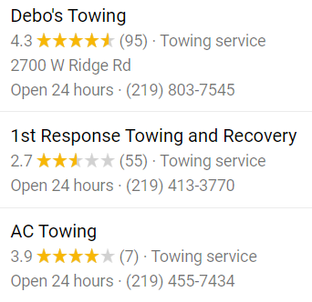
Chicago, IL
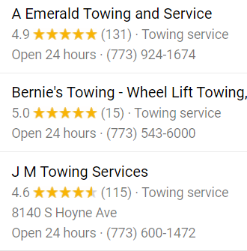
Kankakee, IL
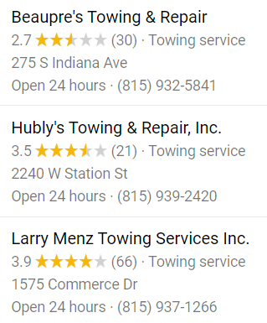
Danforth, IL
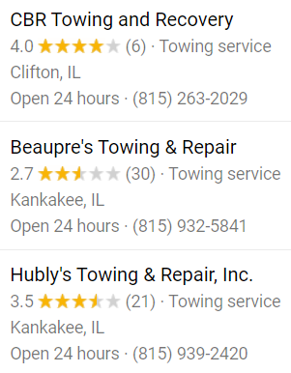
Rantoul, IL
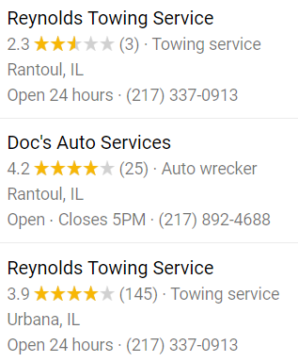
Champaign, IL
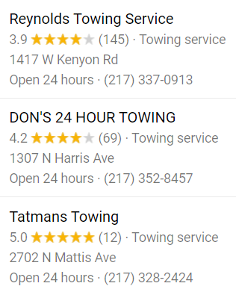
Mattoon, IL
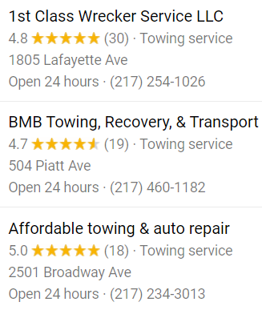
Effingham, IL
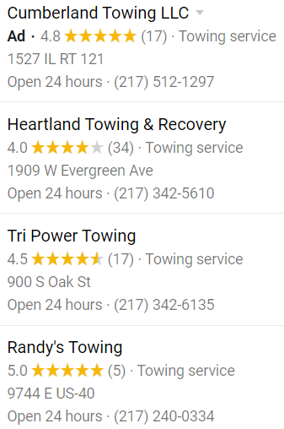
Kinmundy, IL
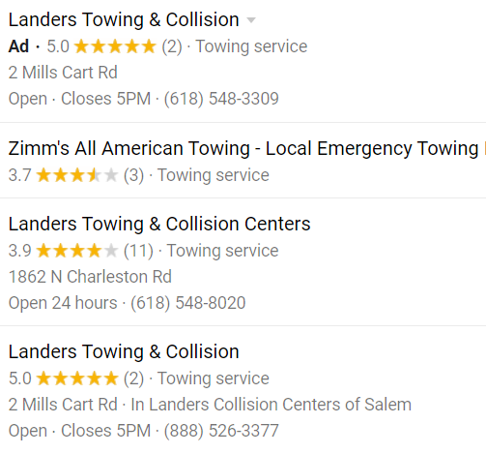
Alma, IL
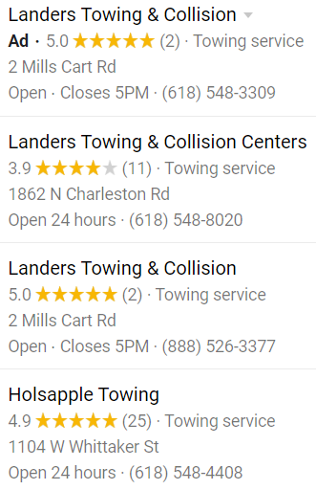
Mount Vernon, IL
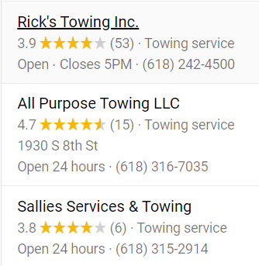
Spring Garden, IL
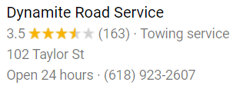
Benton, IL
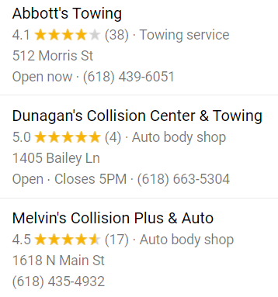
Marion, IL
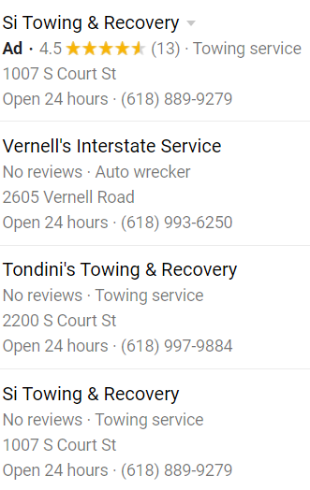
Paducah, KY
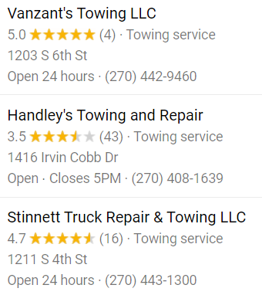
Mayfield, KY
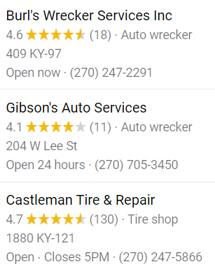
Fulton, KY
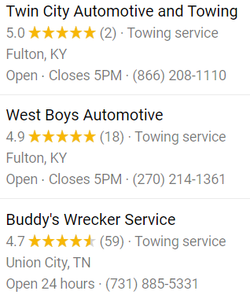
Martin, TN
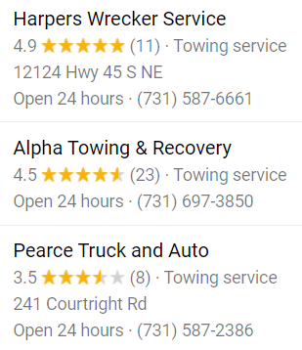
Savannah, TN
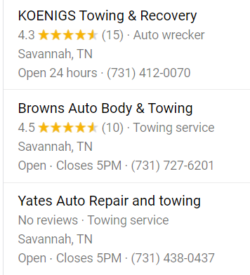
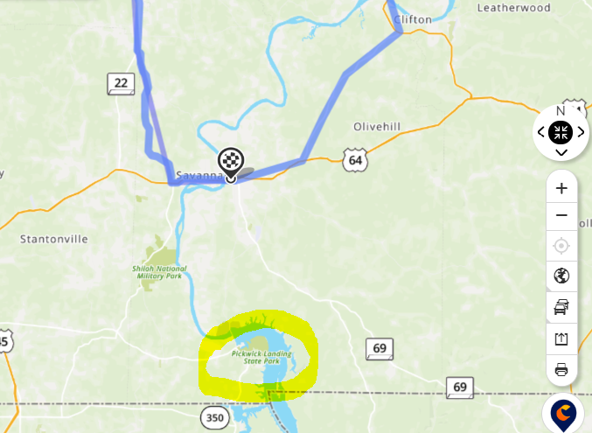
HARTT Transport – Hardin Animal Relocation and Transition Team
(731) 438-5172, Savannah, Tennessee 38372
Welcome to HARTT!
Hardin Animal Relocation and Transition Team (HARTT) is a 501(c) 3 for animals located in Hardin County, TN. We provide life-saving avenues for adoptable animals through transitioning and relocating them from our area of pet overpopulation to areas where they have few adoptable pets. As a foster-based organization, HARTT animals live in volunteer’s foster homes that provide a positive, healthy and loving environment which prepares them to become life-long companions for their adoptive families. We give each individual animal the best care possible – mental, physical and emotional – before allowing them to leave our care.

Quality Inn Savanna - $100 /night (Rewards or discounts)
https://www.choicehotels.com/tennessee/savannah/quality-inn-hotels/tn049?source=gyxt

