G-13 ANIMAL TRANSPORT VIA HSWM VAN

Purpose
This document outlines the process of preparing for a trip, setting up the van with appropriate supplies and provide information for drivers who will be making trips out of the area to pick up animals being transferred from other shelters or rescues

Staff /Areas Affected
• Management
• Transport Coordinator
- Facilities & Maintenance Tech
- Animal Care
- Staff/Volunteer Drivers

Responsibilities
The Transport Coordinator is responsible for most portions of this process. The schedule includes other individuals who are key the success of a transport.

Procedures
1. Management will advise of dates of confirmed transports with source shelters. Once the date, quantity and details of the animals are confirmed, the schedule should be followed to prepare for each transport.
2. Set up for the crates based on the number of adult vs puppies that will be transported
3. Crates must be securely strapped in with ratchet straps.
4. Pack all needed supplies listed on the Transport Supply Checklist
5. Every crate should have a towel and a water bowl inside. No water until after animal pick up.
6. Knowing the number of animals and size are critical to set up of the van with proper number of and size crates.

The following table will provide approximate timelines for each step of the preparation and execution of a transport:

TRANSPORT PLANNING SCHEDULE

WHO |  | WHAT / WHEN
Management | Tania /Holly | Animal Selection  Verify Vet care/vaccines
 |  | TWO WEEKS PRIOR
Trans Coord | Tania / Kathy | Make sure all staff knows that once the crates are set to transport, then cannot be moved or taken out. (The Toyota truck should be used for hauling large loads when transports are scheduled.)
Trans Coord | Tania / Kathy | Maintain sign ups for driving-monitor. confirm
Trans Coord | Tania / Kathy | Confirm drivers and travel dates
Trans Coord | Tania / Kathy | Get copies of D/L. Check driving record
Trans Coord | Tania / Kathy | Review Maint log for Van  Schedule service if needed
Trans Coord | Tania / Kathy | Sign out the van in the mailroom
Trans Coord | Tania / Kathy | Confirm crates & van are clean
Trans Coord | Tania / Kathy | Make Hotel Reservations
Maint Tech | Nic | Confirm AC/Heat is working in the back
Maint Tech | Nic | Schedule oil change if needed
 |  | ONE WEEK PRIOR
Trans Coord | Tania / Kathy | Get transport list of animals and current size of each  Adjust crate set up as needed
Maint Tech | Nic | Confirm AC/Heat is working in the back
Trans Coord | Tania / Kathy | Email Drivers with details – Hotel confirm #, times, etc.
 |  | 3-4 DAYS PRIOR
Trans Coord | Tania / Kathy | Confirm crate set up is adequate for list of animals If not, or different usage is needed reconfigure & secure, with towel inside each
Trans Coord | Tania / Kathy | Put clean towels in each crate
Trans Coord | Tania / Kathy | Confimr there are enough door holders and water bowls for each crate in van
Trans Coord | Tania / Kathy | Confirm adequate supplies are in the van (see supply list) including PPE + extra
Trans Coord | Tania / Kathy | Make sure folder is in the van with SOPs, checklists, emergency protocols, contact info, etc
Trans Coord | Tania / Kathy | Contact drivers for last minute instructions. Advise who if anyone will assist with unload upon return. Remind if Vaccines/meds need to be loaded before leaving.
 |  | ONE DAY PRIOR
Maint Tech | Nic | Start van & verify no maintenance issues
Maint Tech | Nic | Fill gas tank
Trans Coord | Tania / Kathy | Put a supply of bottled water in if possible
Trans Coord | Tania / Kathy | Each crate should have a door mounted water bowl holder
Trans Coord | Tania / Kathy | Get clipboard & keys & advise driver where they will be
Trans Coord | Tania / Kathy | Get credit card from Stephanie, put w keys
Trans Coord | Tania / Kathy | Load any donations go to source shelter
Trans Coord | Tania / Kathy | Confirm w Animal Care return date and WHO is cleaning out the van
Trans Coord | Tania / Kathy | Consider having driver ‘share’ location (iphone users) with someone on staff/unload team
Trans Coord | Tania / Kathy | Confirm location of vaccines/meds & cooler location w Vet Staff *if applicable
 |  | 1-2 DAYS AFTER RETURNING
Trans Coord | Tania / Kathy | Confirm crates and entire van has been cleaned out
Trans Coord | Tania / Kathy | Review Maintenance sheet for any needed repairs
Trans Coord | Tania / Kathy | Contact drivers for an update and details, key/cc location, etc.

TRANSPORT SUPPLY CHECKLIST
Vaccines/Meds for source shelter – if applicable
Water bowls – enough for each crate + 2-3 extra
Bottled water
Puppy slip leads
Adult slip leads
Extra collars/leashes
Soft Treats
Towel inside each crate, + 4-5 extra
Paper Towel and Rescue in a spray bottle
Hand sanitizer & sanitizing wipes
PPE – gloves, masks, gowns, booties, etc. +extra
Extra ratchet straps (above cab)
Human and Animal First Aid Kit
Jumper cables
Folder w Contacts, SOP, emergency protocols, etc.
Insurance paperwork
Remind Driver to review folder prior to leaving
DRIVERS
Phone charger w car adapter (There is a USB port in the van)
Recommended Map Apps (Waze, Apple or Google Maps)
Personal Luggage, masks, meds, water bottle

VEHICLE DETAILS

2014 Dodge Ram ProMaster 2500
Fuel Tank – 24 gal
Height 136” (11.3 ft)
Length 215” (18 ft)
Width 81” (6.75 ft)
Wheelbase 126”
Gross Weight 8,900 lbs,
w crates 9,250, w dogs 9,700

Photos of crate set up in the van’

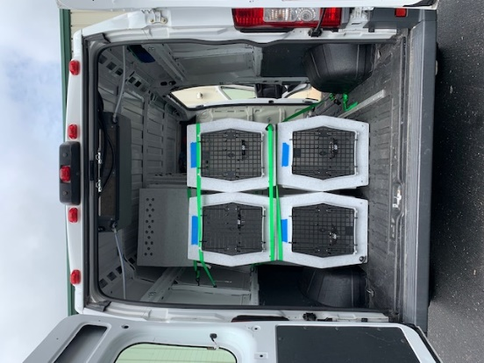 | 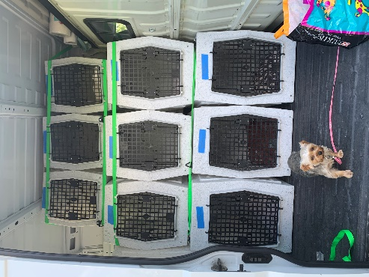
View from Rear doors | View from Side doors

Straps should not encumber crate doors from opening. Straps should be secure at all times. Readjust if movement or vibration has loosened them.

Reference Documents
• Transport Schedule
• Transport Supply Checklist
- G-13 Driver Info

Revision History
V1 - Created 8/14/20

