Happy Empty the Shelters and Bark in the Dark Weekend! The winner of our drawing for last week is Julie. Once you have read this email entirely along with the attachments, please respond and tell me why you choose to work at HSWM. Everyone who responds will be entered in next week's drawing! Here are your updates for the week:

ETS and BID: This weekend will be very busy at the shelter with both Empty the Shelter and Bark in the Dark happening. Please be patient and support your coworkers because we are all going to be very busy. This is a great weekend for both adoptions and fundraising!

ADOPTIONS: Sometime in the next couple of weeks we will be transitioning our adoptions away from appointments and back to our normal walk in procedure. We are still working on details as we are limited to the number of people we can have in the building at one time etc. I just wanted to get it on everyone's radar now. Please stay tuned for more details as they become available.

EMAILS: Please make sure when you receive emails from your co-workers that you acknowledge that you have received them, even if you can't provide the needed information immediately. This will help with sending duplicate requests for information.

STAFF MEETINGS AND HUDDLE: Thank you to everyone that came to huddle and participated in the all staff meeting last week. Please remember that huddle is on Wednesday morning at 9:30 am and all staff that are working are required to attend. Our monthly all staff meetings are also required and are on the 4th Wednesday of each month. Our topic for October is Professionalism in the Work Place.

STAFF RESOURCE CENTER: Beginning Monday, the first cubicle in admin on the right is available for all staff to use for checking emails, watching webinars, etc. This resource is available for any staff member to perform work related tasks.

ANIMAL STATISTICS: Please see the attached document and check out Tania's pretty graphs for our animal statistics. As you can imagine, both our intake and adoption numbers are down compared to last year. We are currently caring for about 200 less animals a month than we did in 2018 and 2019. I will include these statistics on a monthly basis for your review.

COMPASSION FATIGUE: I am attaching Hilary's slides and resource list from the Compassion Fatigue seminar this week. Please keep them for reference and use the resources she has provided. Please remember we have some employee assistance options that are available to staff at no charge as well. That list is posted on the bulletin board in the breakroom and is also available from Steph.

Thanks everyone, have a great weekend!
Holly

August 2020 Animal Statistics

Content:
- Intake/Outcome YTD comparison
Animal intake
- Transfer details
- Animal inventory
- Animal outcome
- Veterinary reviews

Intake/Outcome YTD:
Intake Type 2020 2019 2018  Owner surrender 668 691 907  Returns 169 391 400  Stray 72 105 128  Transfers 704 1,194 1,249  Total 1,613 2,381 2,684 | Outcome Type 2020 2019 2018  Adoption 1,401 2,347 2,370  Died 22 50 25  Euthanasia 56 80 113  Return to owner 23 25 43  Transfer out 4 7 7
Note: These significant differences are consistent with the national trends due to COVID
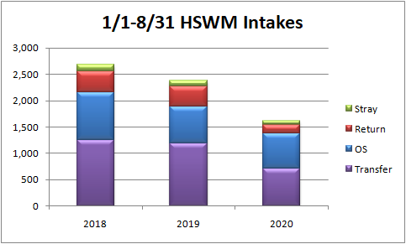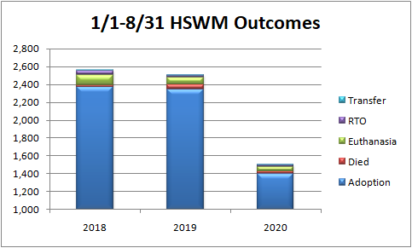

Animal intake:

Animal Intake
 | August 2020 | August 2019 | August 2018
Owner surrender | 155 | 106 | 136
Returns | 19 | 63 | 73
Strays | 13 | 26 | 28
Transfers | 163 | 187 | 193
Total | 350 | 382 | 430

August 2020 Transfers details:
- In state transports- 15
- Out of state transports- 139
- Break down of transfers: 62 rats, 46 dogs, 21 cats, 17 mice, 8 pigs

Animal Inventory:
- Shelter population (includes remaining population plus intakes)
Shelter Population
 | August 2020 | August 2019 | August 2018
Dog | 177 | 178 | 241
Cat | 281 | 546 | 488
Rabbits | 30 | 68 | 40
Other | 104 | 26 | 10
Total | 592 | 818 | 779

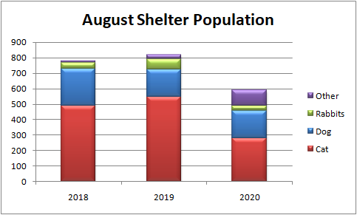

- Care-day based length of stay: August 2020
Species | Avg. days in custody | Avg. days on site | Avg. days available
Dog | 13 | 8 | 4
Cat | 18 | 8 | 6
Rabbit | 23 | 9 | 10

- Care-based length of stay: 2020
Species | Avg. days in custody | Avg. days on site | Avg. days available
Dog | 16 | 11 | 8
Cat | 21 | 11 | 8
Rabbit | 34 | 15 | 14

Animal Outcome:
Animal Outcome
 | August 2020 | August 2019 | August 2018
Adoption | 239 | 355 | 370
Died | 2 | 12 | 3
Euthanasia | 3 | 7 | 9
OR Euthanasia | 24 | 22 | 41
Returned to owner | 6 | 1 | 7
Transfer out | 0 | 0 | 0

August Veterinary reviews:
● Dog spay- 44
● Dog neuter- 36
● Cat spay- 39
● Cat neuter- 40
● Rabbit spay- 8
● Rabbit neuter- 6
- Pig spay- 2
- Pig Neuter- 3
● Verification- 66
● Outpatient heartworm treatments- 21
● Performed $1,625.00 in veterinary services for Hearts of Hope

